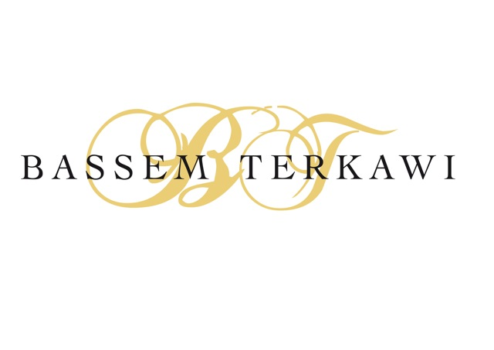PO Box 115018

Dubai, UAE

+971 50 6540230

bassemhoms@hotmail.com

*Professional Experience*

**Senior Director of Strategic Communications**  Oct2006-present

**Tourism Development & Investment Company***Abu Dhabi, UAE*

As a member of TDIC’s senior management team, I contribute to the overall strategic planning of the company’s multi-billion dollar project portfolio whilst collaborating with various departments, as well as Abu Dhabi-based government entities, to instigate marketing and promotional schemes.

*PR Strategies and Communications:* Responsible for planning, budgeting and implementation of communications strategy by spearheading the Public Relations, Internal Communications and CSR units. This involves managing the communication of projects and various initiatives relating to partners and operators, including the British Museum, Guggenheim Foundation, Louvre Museum, Anantara Hotels and Resorts, St. Regis Hotels and Resorts, Westin Hotels and Resorts, and Gary Player Group. Also support residential sales by developing business-to-consumer communication programmes to generate leads.

*Media*: Supervise communication and all PR activities related to brand awareness, media relations, events and campaigns through various channels (TV, print, radio and online). Create innovative PR strategies to promote company across multiple public platforms by delivering groundbreaking news. Act as a spokesperson, authorised to speak on behalf of the company.

Introduced Social Media as a new vehicle within TDIC’s communication scheme by utilising Facebook, Twitter and YouTube.

*Crisis Management, CSR and Investor Relations:* Developed a ‘corporate crisis communications management plan’ encompassing a successful programme of activities to deal with crisis management, damage control and reputation threats. Established Corporate Social Responsibility agenda and launched numerous social and humanitarian initiatives, such as for the welfare of construction workers. Developed, implemented and managed Investor Relations Programme including full communications activities, road shows and media engagement to support TDIC’s bond issuance and market performance.

*Cultural, Educational and Environmental Awareness*: Lead the corporate launch for some of Abu Dhabi’s key tourism and cultural developments, such as Saadiyat Island, Louvre Abu Dhabi museum, Guggenheim Abu Dhabi museum, Zayed National Museum and Qasr Al Sarab Resort. Worked on the re-launch and positioning of Sir Bani Yas Island as the region’s first environmentally friendly tourism destination focusing on wildlife preservation, alternative energy and low-carbon footprint.

*Human Resource Development*: Established and manage a team of seventeen employees from different backgrounds, and deeply contribute to their career development plans. Actively trained a number of Emirati students and coordinators as part of the company’s commitment to Emiratisation programme.

**Public Relations and Events Manager** Aug 2004-Sep 2006

**Dubai Festival City** *Dubai, UAE*

Established PR and event management strategy for Dubai Festival City brand and its individual components, including hotels, residential offerings, shopping complex, schools and offices. Acted as a central point of contact and spokesperson to local and regional officials, general public and media. Actively promoted grand openings, launches of Dubai Festival City’s products and various events engaging the public and media.

**International Public Relations Manager** Sept 2003-July 2004

**Qatar Tourism Authority**  *Doha, Qatar*

Managed the Public Relations Department of Qatar Tourism Authority (QTA) and its regional and international PR agencies. Launched company’s new corporate identity as well as representative offices across prime European destinations, including London, Frankfort, Milan and Moscow. Also represented QTA at international travel trade shows, namely ITB Berlin, WTM London and BIT Milan.

**Public Relations Manager, Middle East** Sept 2001-Sept 2003

**Jumeirah International** *Dubai, UAE and London, UK*

Handled PR for entire group of iconic hotels and managed PR agencies across Germany, UK and Middle East. Established Media Relations with Arabic-speaking press and represented company as spokesperson at all public events. Initiated PR campaign for grand opening of Burj Al Arab which included hosting over 400 media personalities from around the world.

**Regional Media Relations Manager** June 1999-Aug 2001

**Trans-Arabian Communication & Creative Services (TRACCS)** *Dubai, UAE*

Managed accounts of multinationals, such as Dell and Visa International, as well regional companies including Jumeirah International and SHUAA Capital. Set up TRACCS Dubai office through merger of Quantum PR – initiated business planning and recruitment process. Established media relations department in the TRACCS network of eight branches.

**Public Relations Manager** Feb 1997-May1999

**Institute of International Law** *Dubai, UAE*

Promoted the institute’s post-graduate intellectual property courses through media relations, PR activities and direct marketing.

**PR and Communications Executive** Jan 1996-Jan 1997

**Syrian Public Relations Company** *Damascus, Syria*

Supported client services, handled media monitoring and initiated press releases.

*Professional Coaching*

With a passion for corporate life, leadership, mentoring and personal development, I have been dedicated to pursuing coaching as part of my professional career. Over the years, I have coached groups of fresh graduates and inspired them to excel in their careers, while capitalising on my strong communication skills (in Arabic and English). As a professionally trained public speaker, I have lectured extensively such as to Jumeirah Group’s concierges on hospitality and Zayed University students on succeeding through the art of communication.

**Life Skills Coaching Diploma** Feb-Jan 2012

**Stone Bridge University** London, UK

Curriculum focused on professional training and incorporated a full range of therapeutic models including: basic counselling, psychoanalysis, cognitive behaviour therapy (CBT), advanced coaching techniques, neuro-linguistic programming (NLP) and self-hypnosis.

**Co-Active Coaching**  Jan 2012-present

**Coaches Training Institute (CTI)** Dubai, UAE

Completed to the core curriculum and due to graduate as a **Certified Coach (CPCC)** in Sep 2013. CTI is one of the world’s leading coaches training organisation with thousands of graduated coaches.

Authoring a book on personal development titled *Coach Yourself to Success*to help people achieve outstanding empowerment and leadership skills while maintaining internal balance and embracing practical and positive growth. *To be published in June 2014.*

*Training and Workshops*

Development **Breakthrough to Success** 2012

Jack Canfield *Phoenix, Arizona*

Body Language **Body Language Skills** 2012

Allan Pease *Dubai, UAE*

Leadership **Leadership Development Programme** 2010

Centre for Creative Leadership (CCL)  *Colorado, USA*

Protocol **Diploma in Advanced International Protocol and Etiquette** 2009

Washington School of Protocol *Washington DC, USA*

Management **The 7 Habits of Highly Effective People** 2003

Franklin Covey *Dubai, UAE*

# Media Relations Linguistic Sciences on Media Relations 2001

Hann International Educational Center *Amsterdam, Holland*

# 

*Education*

**Bachelor of Science (Law Degree)** 1991-1996

*Beirut Arab University* *Beirut, Lebanon*

**Baccalaureate in Sciences** 1991

*Austrian St. Nikolas College Homs, Syria*

**Higher Diploma in Intellectual Property** 1997-1998

*Switzerland World Intellectual Property Organization Geneva, Switzerland*

*Languages*

Fluent in Arabic and English

*Membership of Professional Bodies*

Middle East Shopping Centres in Dubai, UAE (member since 2003)

International Arbitration Center in Paris, France (member since 1998)

*Interests*

Coaching and personal development, experiencing world cultures through travelling, writing poetry, coordinating humanitarian relief and fundraising activities

*Volunteer work*: Red Cross Syria

*References*

Available upon request

*Personal Info*

Nationality: Syrian

Date of birth: August 19, 1973

Marital status: Single